What Smart Thermostats Mean for the Future of HVAC

The future of HVAC is smart technology. Here’s why your HVAC business will benefit.

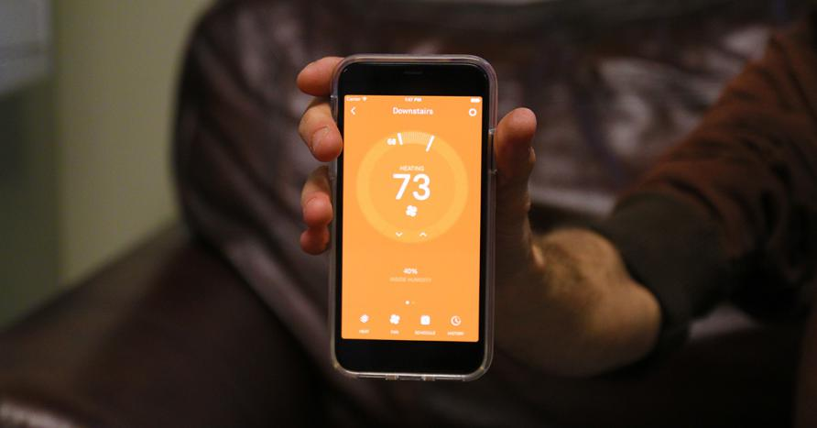

Household climate was once accepted as static, like that draft in the living room that you always find in the same place. However, thanks to the [smart technologies](https://www.smartservice.com/smart-service-blog/best-of-ahr-2018/) of recent years, even HVAC systems have come alive, gaining brains just like the scarecrow from The Wizard of Oz. That’s right, I’m talking about smart thermostats.

Smart thermostats like [Nest](https://nest.com/) can do all the things normal thermostats can do, just more and better. Because smart thermostats are connected to your phone and other devices, you can control your HVAC from virtually anywhere. They save households money, look sleek, and are compatible with most HVAC units.

As a result, smart thermostats have taken shack in [17.5 million homes across North America](https://www.statista.com/statistics/625868/homes-with-smart-thermostats-in-north-america/), and they’re not stopping. Numbers are expected to nearly double in the next two years alone as people seek for more interconnectivity between everyday devices and activities.

When any industry is faced with change, people tend to freak out. “What will this mean for my job? For my business? Am I—*shudders*—redundant?”

Sometimes change can be for the good of everyone. In this case, the HVAC industry has nothing to worry about, and, perhaps, everything to look forward to.

IoT in Our Homes

When more than [40% of Americans have smart home technology and 16% have a smart speaker](https://techcrunch.com/2018/01/12/39-million-americans-now-own-a-smart-speaker-report-claims/), it is obvious that IoT, or the internet of things (the network that connects all our smart devices), is here for the long run.

It makes sense; smart technology makes life easier. Communication between our smart devices can make us healthier and happier, encouraging us to reach those 10,000 steps a day, save money on our energy bills, and even remember to pick up the kids at 3 PM. Once you’ve tasted the apple, it’s easy to fall into the luxury and ease that IoT offers.

Smart thermostats are no different. They provide transparency to a construct that people didn’t even think about prior to their invention.

With smart thermostats, people can suddenly see the cause and effect of their actions (or lack thereof) on their energy bills. Your AC unit needs maintenance? That’ll show in your energy usage. Your heater needs cleaned out? Yep, that’ll appear in air quality.

Consequences, and the rewards when good habits are maintained, contribute to active consumer involvement and interest in HVAC.

The Prominence of Smart AC Units

While people have taken to smart thermostats, this technology only scratches the surface of smart HVAC. Smart thermostats represent just the user interface of a larger system. Smart HVAC tech will become more widespread, down to the units and even vents.

Because HVAC units are not as easily replaceable as thermostats, it could be a while before smart HVAC units become mainstream. However, since HVAC companies deal with lots of system replacements and new construction, smarter systems will ultimately become a prominent part of HVAC industry revenue.

People Caring More About Their Systems

It is easy to forget about something when you can’t see it, but when your trustworthy smartphone tells you a filter needs changed, suddenly the matter becomes much more pressing. You can’t be blissfully ignorant when you have all the data in your hand.

This will result in people taking more of an active interest in the maintenance of their HVAC units. That means more preventative maintenance agreements and regular work for HVAC companies. Consumers will no longer wait for a unit to stop working entirely before taking action.

Maintenance Repairs Based on App Diagnostics

With the prevalence of automated subscriptions and services, it is unsurprising that the same industry shift will occur in HVAC. If people can get oil changes brought to them, the same thing can occur with HVAC needs.

In the near future, it is possible that people will “subscribe” to HVAC companies. HVAC maintenance plans can go one step further than they do currently. How? By receiving diagnostic information from your customers’ smart technology. If something goes awry, HVAC companies can call the customer directly to see if they would like the issue taken care of instead of waiting for something more damaging to occur.

Conclusion

Times are changing, but if you’re working in HVAC, there’s no need to be worried. Smart thermostats are just the start of what will be a huge shift in the way people think about and use HVAC systems. Smarter HVAC means more concerned consumers and better diagnostics. As houses become more interconnected through IoT, so will your HVAC company to your customers.

From：<https://www.smartservice.com/smart-service-blog/what-smart-thermostats-mean-for-the-future-of-hvac/>